Module1:Design Pattern and Principles
1: Implementing the Singleton Pattern
class Logger {
// Single instance
private static Logger instance;
// Private constructor
private Logger() {
System.out.println("Logger Instance Created");
}
// Method to get the single instance
public static Logger getInstance() {
if (instance == null) {
instance = new Logger();
}
return instance;
}
// Log method
public void log(String message) {
System.out.println("[LOG] " + message);
}
}
public class SingletonPattern {
public static void main(String[] args) {
Logger logger1 = Logger.getInstance();
logger1.log("Application Started");
Logger logger2 = Logger.getInstance();
logger2.log("Logging Another Message");
if (logger1 == logger2) {
System.out.println("\nSingleton Pattern Verified");
System.out.println("Only One Instance Exists.");
} else {
System.out.println("Multiple Instances Created.");
}
System.out.println("\nLogger1 HashCode : " + logger1.hashCode());
System.out.println("Logger2 HashCode : " + logger2.hashCode());
}
}

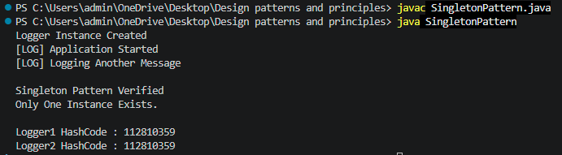

2: Implementing the Factory Method Pattern
class FactoryMethodPattern {
}
// Document Interface
interface Document {
void open();
}
// Word Document
class WordDocument implements Document {
public void open() {
System.out.println("Opening Word Document");
}
}
// PDF Document
class PdfDocument implements Document {
public void open() {
System.out.println("Opening PDF Document");
}
}
// Excel Document
class ExcelDocument implements Document {
public void open() {
System.out.println("Opening Excel Document");
}
}
// Abstract Factory
abstract class DocumentFactory {
abstract Document createDocument();
}
// Word Factory
class WordFactory extends DocumentFactory {
public Document createDocument() {
return new WordDocument();
}
}
// PDF Factory
class PdfFactory extends DocumentFactory {
public Document createDocument() {
return new PdfDocument();
}
}
// Excel Factory
class ExcelFactory extends DocumentFactory {
public Document createDocument() {
return new ExcelDocument();
}
}
// Main Class
public class FactoryMethod {
public static void main(String[] args) {
DocumentFactory factory;
// Create Word Document
factory = new WordFactory();
Document word = factory.createDocument();
word.open();
// Create PDF Document
factory = new PdfFactory();
Document pdf = factory.createDocument();
pdf.open();
// Create Excel Document
factory = new ExcelFactory();
Document excel = factory.createDocument();
excel.open();
}
}
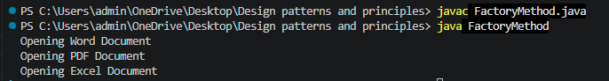

3: Implementing the Builder Pattern
// Computer Class
class Computer {
private String cpu;
private int ram;
private int storage;
private String gpu;
// Private Constructor
private Computer(Builder builder) {
this.cpu = builder.cpu;
this.ram = builder.ram;
this.storage = builder.storage;
this.gpu = builder.gpu;
}
// Display Computer Details
public void display() {
System.out.println("Computer Configuration");
System.out.println("----------------------");
System.out.println("CPU : " + cpu);
System.out.println("RAM : " + ram + " GB");
System.out.println("Storage : " + storage + " GB");
System.out.println("GPU : " + gpu);
System.out.println();
}
// Static Nested Builder Class
static class Builder {
private String cpu;
private int ram;
private int storage;
private String gpu;
public Builder setCPU(String cpu) {
this.cpu = cpu;
return this;
}
public Builder setRAM(int ram) {
this.ram = ram;
return this;
}
public Builder setStorage(int storage) {
this.storage = storage;
return this;
}
public Builder setGPU(String gpu) {
this.gpu = gpu;
return this;
}
public Computer build() {
return new Computer(this);
}
}
}
// Main Class
public class BuilderPattern {
public static void main(String[] args) {
// Gaming Computer
Computer gamingPC = new Computer.Builder()
.setCPU("Intel Core i9")
.setRAM(32)
.setStorage(1000)
.setGPU("NVIDIA RTX 4080")
.build();
// Office Computer
Computer officePC = new Computer.Builder()
.setCPU("Intel Core i5")
.setRAM(16)
.setStorage(512)
.setGPU("Integrated Graphics")
.build();
System.out.println("Gaming PC");
gamingPC.display();
System.out.println("Office PC");
officePC.display();
}
}
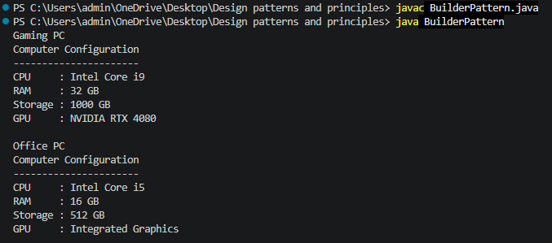
4: Implementing the Adapter Pattern
// Target Interface
interface PaymentProcessor {
void processPayment(double amount);
}
// Adaptee 1 - PayPal Gateway
class PayPalGateway {
public void makePayment(double amount) {
System.out.println("Payment of Rs." + amount + " processed using PayPal.");
}
}
// Adaptee 2 - Stripe Gateway
class StripeGateway {
public void pay(double amount) {
System.out.println("Payment of Rs." + amount + " processed using Stripe.");
}
}
// Adapter for PayPal
class PayPalAdapter implements PaymentProcessor {
private PayPalGateway paypal;
public PayPalAdapter() {
paypal = new PayPalGateway();
}
public void processPayment(double amount) {
paypal.makePayment(amount);
}
}
// Adapter for Stripe
class StripeAdapter implements PaymentProcessor {
private StripeGateway stripe;
public StripeAdapter() {
stripe = new StripeGateway();
}
public void processPayment(double amount) {
stripe.pay(amount);
}
}
// Main Class
public class AdapterPattern {
public static void main(String[] args) {
PaymentProcessor payment;
// Using PayPal
payment = new PayPalAdapter();
payment.processPayment(2500);
// Using Stripe
payment = new StripeAdapter();
payment.processPayment(5000);
}
}
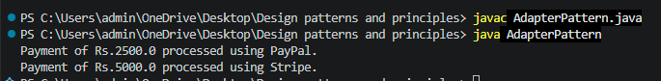
5: Implementing the Decorator Pattern
// Component Interface
interface Notifier {
void send(String message);
}
// Concrete Component
class EmailNotifier implements Notifier {
public void send(String message) {
System.out.println("Sending Email Notification: " + message);
}
}
// Abstract Decorator
abstract class NotifierDecorator implements Notifier {
protected Notifier notifier;
public NotifierDecorator(Notifier notifier) {
this.notifier = notifier;
}
public void send(String message) {
notifier.send(message);
}
}
// SMS Decorator
class SMSNotifierDecorator extends NotifierDecorator {
public SMSNotifierDecorator(Notifier notifier) {
super(notifier);
}
public void send(String message) {
super.send(message);
sendSMS(message);
}
private void sendSMS(String message) {
System.out.println("Sending SMS Notification: " + message);
}
}
// Slack Decorator
class SlackNotifierDecorator extends NotifierDecorator {
public SlackNotifierDecorator(Notifier notifier) {
super(notifier);
}
public void send(String message) {
super.send(message);
sendSlack(message);
}
private void sendSlack(String message) {
System.out.println("Sending Slack Notification: " + message);
}
}
// Main Class
public class DecoratorPattern {
public static void main(String[] args) {
// Only Email Notification
Notifier email = new EmailNotifier();
System.out.println("Email Only:");
email.send("Your order has been placed.");
System.out.println();
// Email + SMS Notification
Notifier emailSMS = new SMSNotifierDecorator(email);
System.out.println("Email + SMS:");
emailSMS.send("Your order has been shipped.");
System.out.println();
// Email + SMS + Slack Notification
Notifier allNotifications =
new SlackNotifierDecorator(
new SMSNotifierDecorator(
new EmailNotifier()
)
);
System.out.println("Email + SMS + Slack:");
allNotifications.send("Your payment was successful.");
}
}
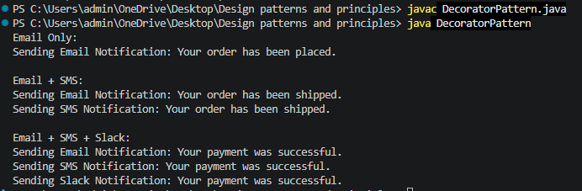
6: Implementing the Proxy Pattern
// Subject Interface
interface Image {
void display();
}
// Real Subject Class
class RealImage implements Image {
private String fileName;
public RealImage(String fileName) {
this.fileName = fileName;
loadImageFromServer();
}
private void loadImageFromServer() {
System.out.println("Loading image from remote server: " + fileName);
}
public void display() {
System.out.println("Displaying image: " + fileName);
}
}
// Proxy Class
class ProxyImage implements Image {
private String fileName;
private RealImage realImage;
public ProxyImage(String fileName) {
this.fileName = fileName;
}
public void display() {
// Lazy initialization
if (realImage == null) {
realImage = new RealImage(fileName);
}
// Display image
realImage.display();
}
}
// Main Class
public class ProxyPattern {
public static void main(String[] args) {
Image image = new ProxyImage("nature.jpg");
System.out.println("First call:");
image.display();
System.out.println();
System.out.println("Second call:");
image.display();
}
}
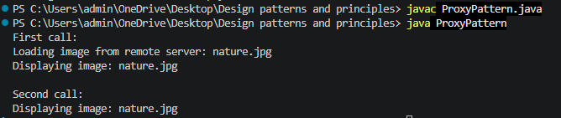
7: Implementing the Observer Pattern
import java.util.ArrayList;
import java.util.List;
// Observer Interface
interface Observer {
void update(String stockName, double price);
}
// Subject Interface
interface Stock {
void registerObserver(Observer observer);
void removeObserver(Observer observer);
void notifyObservers();
}
// Concrete Subject
class StockMarket implements Stock {
private List<Observer> observers = new ArrayList<>();
private String stockName;
private double price;
public void registerObserver(Observer observer) {
observers.add(observer);
}
public void removeObserver(Observer observer) {
observers.remove(observer);
}
public void notifyObservers() {
for (Observer observer : observers) {
observer.update(stockName, price);
}
}
public void setStockPrice(String name, double price) {
this.stockName = name;
this.price = price;
System.out.println("\nStock Price Updated");
notifyObservers();
}
}
// Concrete Observer - Mobile App
class MobileApp implements Observer {
public void update(String stockName, double price) {
System.out.println(
"Mobile App: " + stockName +
" price changed to Rs." + price
);
}
}
// Concrete Observer - Web App
class WebApp implements Observer {
public void update(String stockName, double price) {
System.out.println(
"Web App: " + stockName +
" price changed to Rs." + price
);
}
}
// Main Class
public class ObserverPattern {
public static void main(String[] args) {
StockMarket market = new StockMarket();
Observer mobile = new MobileApp();
Observer web = new WebApp();
// Register observers
market.registerObserver(mobile);
market.registerObserver(web);
// Change stock price
market.setStockPrice("TCS", 3500);
market.setStockPrice("INFOSYS", 1600);
// Remove observer
market.removeObserver(web);
market.setStockPrice("WIPRO", 500);
}
}
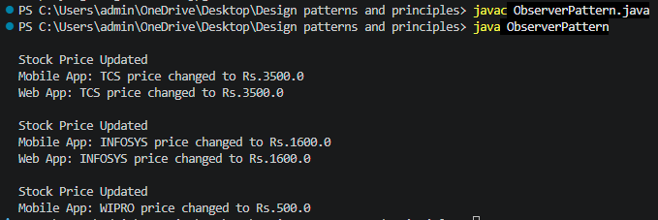
8: Implementing the Strategy Pattern
// Strategy Interface
interface PaymentStrategy {
void pay(double amount);
}
// Concrete Strategy - Credit Card Payment
class CreditCardPayment implements PaymentStrategy {
private String cardNumber;
public CreditCardPayment(String cardNumber) {
this.cardNumber = cardNumber;
}
public void pay(double amount) {
System.out.println(
"Paid Rs." + amount +
" using Credit Card"
);
System.out.println(
"Card Number: " + cardNumber
);
}
}
// Concrete Strategy - PayPal Payment
class PayPalPayment implements PaymentStrategy {
private String email;
public PayPalPayment(String email) {
this.email = email;
}
public void pay(double amount) {
System.out.println(
"Paid Rs." + amount +
" using PayPal"
);
System.out.println(
"PayPal Account: " + email
);
}
}
// Context Class
class PaymentContext {
private PaymentStrategy strategy;
public void setPaymentStrategy(PaymentStrategy strategy) {
this.strategy = strategy;
}
public void executePayment(double amount) {
if (strategy == null) {
System.out.println("Payment Method Not Selected");
}
else {
strategy.pay(amount);
}
}
}
// Main Class
public class StrategyPattern {
public static void main(String[] args) {
PaymentContext context = new PaymentContext();
// Using Credit Card Payment
context.setPaymentStrategy(
new CreditCardPayment("1234-5678-9012")
);
context.executePayment(5000);
System.out.println();
// Using PayPal Payment
context.setPaymentStrategy(
new PayPalPayment("user@gmail.com")
);
context.executePayment(3000);
}
}
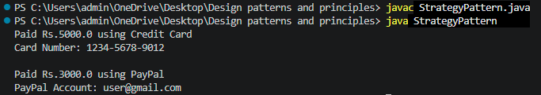

9: Implementing the Command Pattern
// Command Interface
interface Command {
void execute();
}
// Receiver Class
class Light {
public void turnOn() {
System.out.println("Light is ON");
}
public void turnOff() {
System.out.println("Light is OFF");
}
}
// Concrete Command - Turn ON
class LightOnCommand implements Command {
private Light light;
public LightOnCommand(Light light) {
this.light = light;
}
public void execute() {
light.turnOn();
}
}
// Concrete Command - Turn OFF
class LightOffCommand implements Command {
private Light light;
public LightOffCommand(Light light) {
this.light = light;
}
public void execute() {
light.turnOff();
}
}
// Invoker Class
class RemoteControl {
private Command command;
public void setCommand(Command command) {
this.command = command;
}
public void pressButton() {
if (command != null) {
command.execute();
}
else {
System.out.println("No Command Assigned");
}
}
}
// Main Class
public class CommandPattern {
public static void main(String[] args) {
// Receiver
Light light = new Light();
// Commands
Command lightOn =
new LightOnCommand(light);
Command lightOff =
new LightOffCommand(light);
// Invoker
RemoteControl remote = new RemoteControl();
// Turn ON Light
System.out.println("Press ON Button:");
remote.setCommand(lightOn);
remote.pressButton();
System.out.println();
// Turn OFF Light
System.out.println("Press OFF Button:");
remote.setCommand(lightOff);
remote.pressButton();
}
}
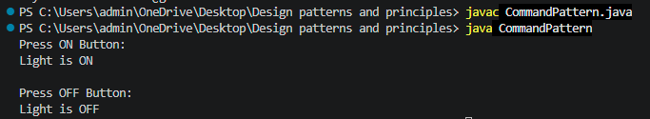
10: Implementing the MVC Pattern
// Model Class
class Student {
private String name;
private int id;
private String grade;
public Student(String name, int id, String grade) {
this.name = name;
this.id = id;
this.grade = grade;
}
public String getName() {
return name;
}
public int getId() {
return id;
}
public String getGrade() {
return grade;
}
public void setName(String name) {
this.name = name;
}
public void setGrade(String grade) {
this.grade = grade;
}
}
// View Class
class StudentView {
public void displayStudentDetails(String name, int id, String grade) {
System.out.println("Student Details");
System.out.println("----------------");
System.out.println("Name : " + name);
System.out.println("ID : " + id);
System.out.println("Grade : " + grade);
}
}
// Controller Class
class StudentController {
private Student model;
private StudentView view;
public StudentController(Student model, StudentView view) {
this.model = model;
this.view = view;
}
public void setStudentName(String name) {
model.setName(name);
}
public void setStudentGrade(String grade) {
model.setGrade(grade);
}
public void updateView() {
view.displayStudentDetails(
model.getName(),
model.getId(),
model.getGrade()
);
}
}
// Main Class
public class MVC {
public static void main(String[] args) {
// Create Model
Student student =
new Student("Lahari", 101, "A");
// Create View
StudentView view =
new StudentView();
// Create Controller
StudentController controller =
new StudentController(student, view);
// Display Initial Details
System.out.println("Before Update:");
controller.updateView();
System.out.println();
// Update Student Details using Controller
controller.setStudentName("Kavya");
controller.setStudentGrade("A+");
// Display Updated Details
System.out.println("After Update:");
controller.updateView();
}
}
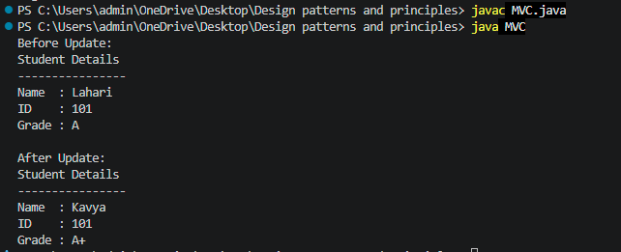

11: Implementing Dependency Injection
// Repository Interface
interface CustomerRepository {
String findCustomerById(int id);
}
// Concrete Repository Class
class CustomerRepositoryImpl implements CustomerRepository {
public String findCustomerById(int id) {
if (id == 101) {
return "Customer Found: Lahari";
}
else {
return "Customer Not Found";
}
}
}
// Service Class
class CustomerService {
private CustomerRepository repository;
// Constructor Injection
public CustomerService(CustomerRepository repository) {
this.repository = repository;
}
public void getCustomer(int id) {
String customer =
repository.findCustomerById(id);
System.out.println(customer);
}
}
// Main Class
public class DependencyPattern {
public static void main(String[] args) {
// Creating Repository Object
CustomerRepository repository =
new CustomerRepositoryImpl();
// Injecting Repository Dependency into Service
CustomerService service =
new CustomerService(repository);
// Using Service
service.getCustomer(101);
service.getCustomer(200);
}
}
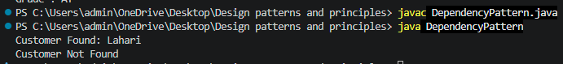

Module 2:Data Structures and Algorithms
1: Inventory Management System
import java.util.*;
class Product {
int productId;
String productName;
int quantity;
double price;
Product(int id, String name, int qty, double price) {
this.productId = id;
this.productName = name;
this.quantity = qty;
this.price = price;
}
public String toString() {
return productId + " " + productName + " " + quantity + " " + price;
}
}
public class Inventory {
public static void main(String[] args) {
HashMap<Integer, Product> inventory = new HashMap<>();
// Add
inventory.put(1, new Product(1, "Laptop", 10, 50000));
inventory.put(2, new Product(2, "Mouse", 20, 500));
// Update
inventory.get(1).quantity = 15;
// Delete
inventory.remove(2);
// Display
for (Product p : inventory.values()) {
System.out.println(p);
}
}
}
2: E-commerce Platform Search Function
import java.util.*;
class Product {
int id;
String name;
Product(int id, String name) {
this.id = id;
this.name = name;
}
}
public class Search {
static void linearSearch(Product arr[], String key) {
for (Product p : arr) {
if (p.name.equalsIgnoreCase(key)) {
System.out.println("Found");
return;
}
}
System.out.println("Not Found");
}
static void binarySearch(Product arr[], String key) {
int low = 0, high = arr.length - 1;
while (low <= high) {
int mid = (low + high) / 2;
int res = arr[mid].name.compareToIgnoreCase(key);
if (res == 0) {
System.out.println("Found");
return;
} else if (res < 0)
low = mid + 1;
else
high = mid - 1;
}
System.out.println("Not Found");
}
public static void main(String[] args) {
Product arr[] = {
new Product(1, "Apple"),
new Product(2, "Banana"),
new Product(3, "Laptop"),
new Product(4, "Mobile")
};
linearSearch(arr, "Laptop");
Arrays.sort(arr, Comparator.comparing(a -> a.name));
binarySearch(arr, "Laptop");
}
}
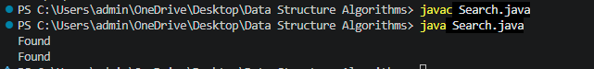
3: Sorting Customer Orders
class Order {
int id;
String customer;
double price;
Order(int id, String customer, double price) {
this.id = id;
this.customer = customer;
this.price = price;
}
}
public class Sorting {
static void bubbleSort(Order arr[]) {
for (int i = 0; i < arr.length - 1; i++) {
for (int j = 0; j < arr.length - i - 1; j++) {
if (arr[j].price > arr[j + 1].price) {
Order t = arr[j];
arr[j] = arr[j + 1];
arr[j + 1] = t;
}
}
}
}
static int partition(Order arr[], int low, int high) {
double pivot = arr[high].price;
int i = low - 1;
for (int j = low; j < high; j++) {
if (arr[j].price < pivot) {
i++;
Order t = arr[i];
arr[i] = arr[j];
arr[j] = t;
}
}
Order t = arr[i + 1];
arr[i + 1] = arr[high];
arr[high] = t;
return i + 1;
}
static void quickSort(Order arr[], int low, int high) {
if (low < high) {
int pi = partition(arr, low, high);
quickSort(arr, low, pi - 1);
quickSort(arr, pi + 1, high);
}
}
public static void main(String args[]) {
Order arr[] = {
new Order(1, "A", 500),
new Order(2, "B", 200),
new Order(3, "C", 800)
};
quickSort(arr, 0, arr.length - 1);
for (Order o : arr)
System.out.println(o.id + " " + o.price);
}
}
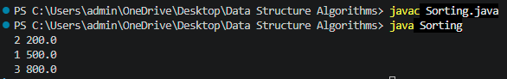

4: Employee Management System
class Employee {
int id;
String name;
String position;
double salary;
Employee(int id, String name, String position, double salary) {
this.id = id;
this.name = name;
this.position = position;
this.salary = salary;
}
}
public class EmployeeManagement {
public static void main(String args[]) {
Employee emp[] = new Employee[5];
emp[0] = new Employee(1, "Ram", "Manager", 50000);
emp[1] = new Employee(2, "Ravi", "Developer", 40000);
// Traverse
for (Employee e : emp) {
if (e != null)
System.out.println(e.id + " " + e.name);
}
// Search
int key = 2;
for (Employee e : emp) {
if (e != null && e.id == key)
System.out.println("Found " + e.name);
}
// Delete
emp[1] = null;
}
}
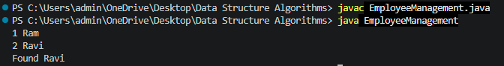

5: Task Management System
class Task {
int taskId;
String taskName;
String status;
Task next;
Task(int id, String name, String status) {
taskId = id;
taskName = name;
this.status = status;
}
}
public class SingleyLinkedList {
static Task head = null;
static void add(int id, String name, String status) {
Task t = new Task(id, name, status);
if (head == null)
head = t;
else {
Task temp = head;
while (temp.next != null)
temp = temp.next;
temp.next = t;
}
}
static void search(int id) {
Task temp = head;
while (temp != null) {
if (temp.taskId == id) {
System.out.println("Task Found");
System.out.println(temp.taskId + " " + temp.taskName + " " + temp.status);
return;
}
temp = temp.next;
}
System.out.println("Task Not Found");
}
static void display() {
Task temp = head;
while (temp != null) {
System.out.println(temp.taskId + " " + temp.taskName + " " + temp.status);
temp = temp.next;
}
}
static void delete(int id) {
if (head == null)
return;
if (head.taskId == id) {
head = head.next;
return;
}
Task temp = head;
while (temp.next != null && temp.next.taskId != id)
temp = temp.next;
if (temp.next != null)
temp.next = temp.next.next;
}
public static void main(String[] args) {
add(1, "Coding", "Pending");
add(2, "Testing", "Completed");
add(3, "Debugging", "Pending");
System.out.println("Task List:");
display();
search(2);
delete(2);
System.out.println("\nAfter Deletion:");
display();
}
}
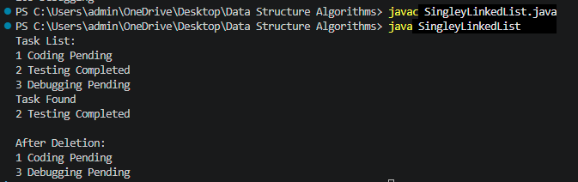

6: Library Management System
import java.util.Arrays;
import java.util.Comparator;
class Book {
int bookId;
String title;
String author;
Book(int id, String title, String author) {
bookId = id;
this.title = title;
this.author = author;
}
}
public class LibraryManagment {
static void linearSearch(Book b[], String key) {
for (Book x : b) {
if (x.title.equalsIgnoreCase(key)) {
System.out.println("Book Found: " + x.title);
return;
}
}
System.out.println("Book Not Found");
}
static void binarySearch(Book b[], String key) {
int low = 0, high = b.length - 1;
while (low <= high) {
int mid = (low + high) / 2;
int c = b[mid].title.compareToIgnoreCase(key);
if (c == 0) {
System.out.println("Book Found: " + b[mid].title);
return;
} else if (c < 0)
low = mid + 1;
else
high = mid - 1;
}
System.out.println("Book Not Found");
}
public static void main(String[] args) {
Book books[] = {
new Book(1, "C", "Dennis"),
new Book(2, "Java", "James"),
new Book(3, "Python", "Guido"),
new Book(4, "SQL", "Oracle")
};
System.out.println("Linear Search:");
linearSearch(books, "Python");
Arrays.sort(books, Comparator.comparing(a -> a.title));
System.out.println("Binary Search:");
binarySearch(books, "Python");
}
}
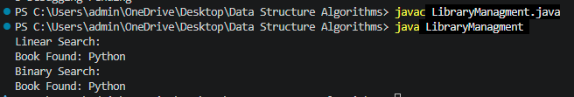

7: Financial Forecasting
public class Forecasting {
static double futureValue(double amount, double rate, int years) {
if (years == 0)
return amount;
return futureValue(amount * (1 + rate), rate, years - 1);
}
public static void main(String[] args) {
double principal = 10000;
double growthRate = 0.10;
int years = 5;
double result = futureValue(principal, growthRate, years);
System.out.println("Future Value = " + result);
}
}

